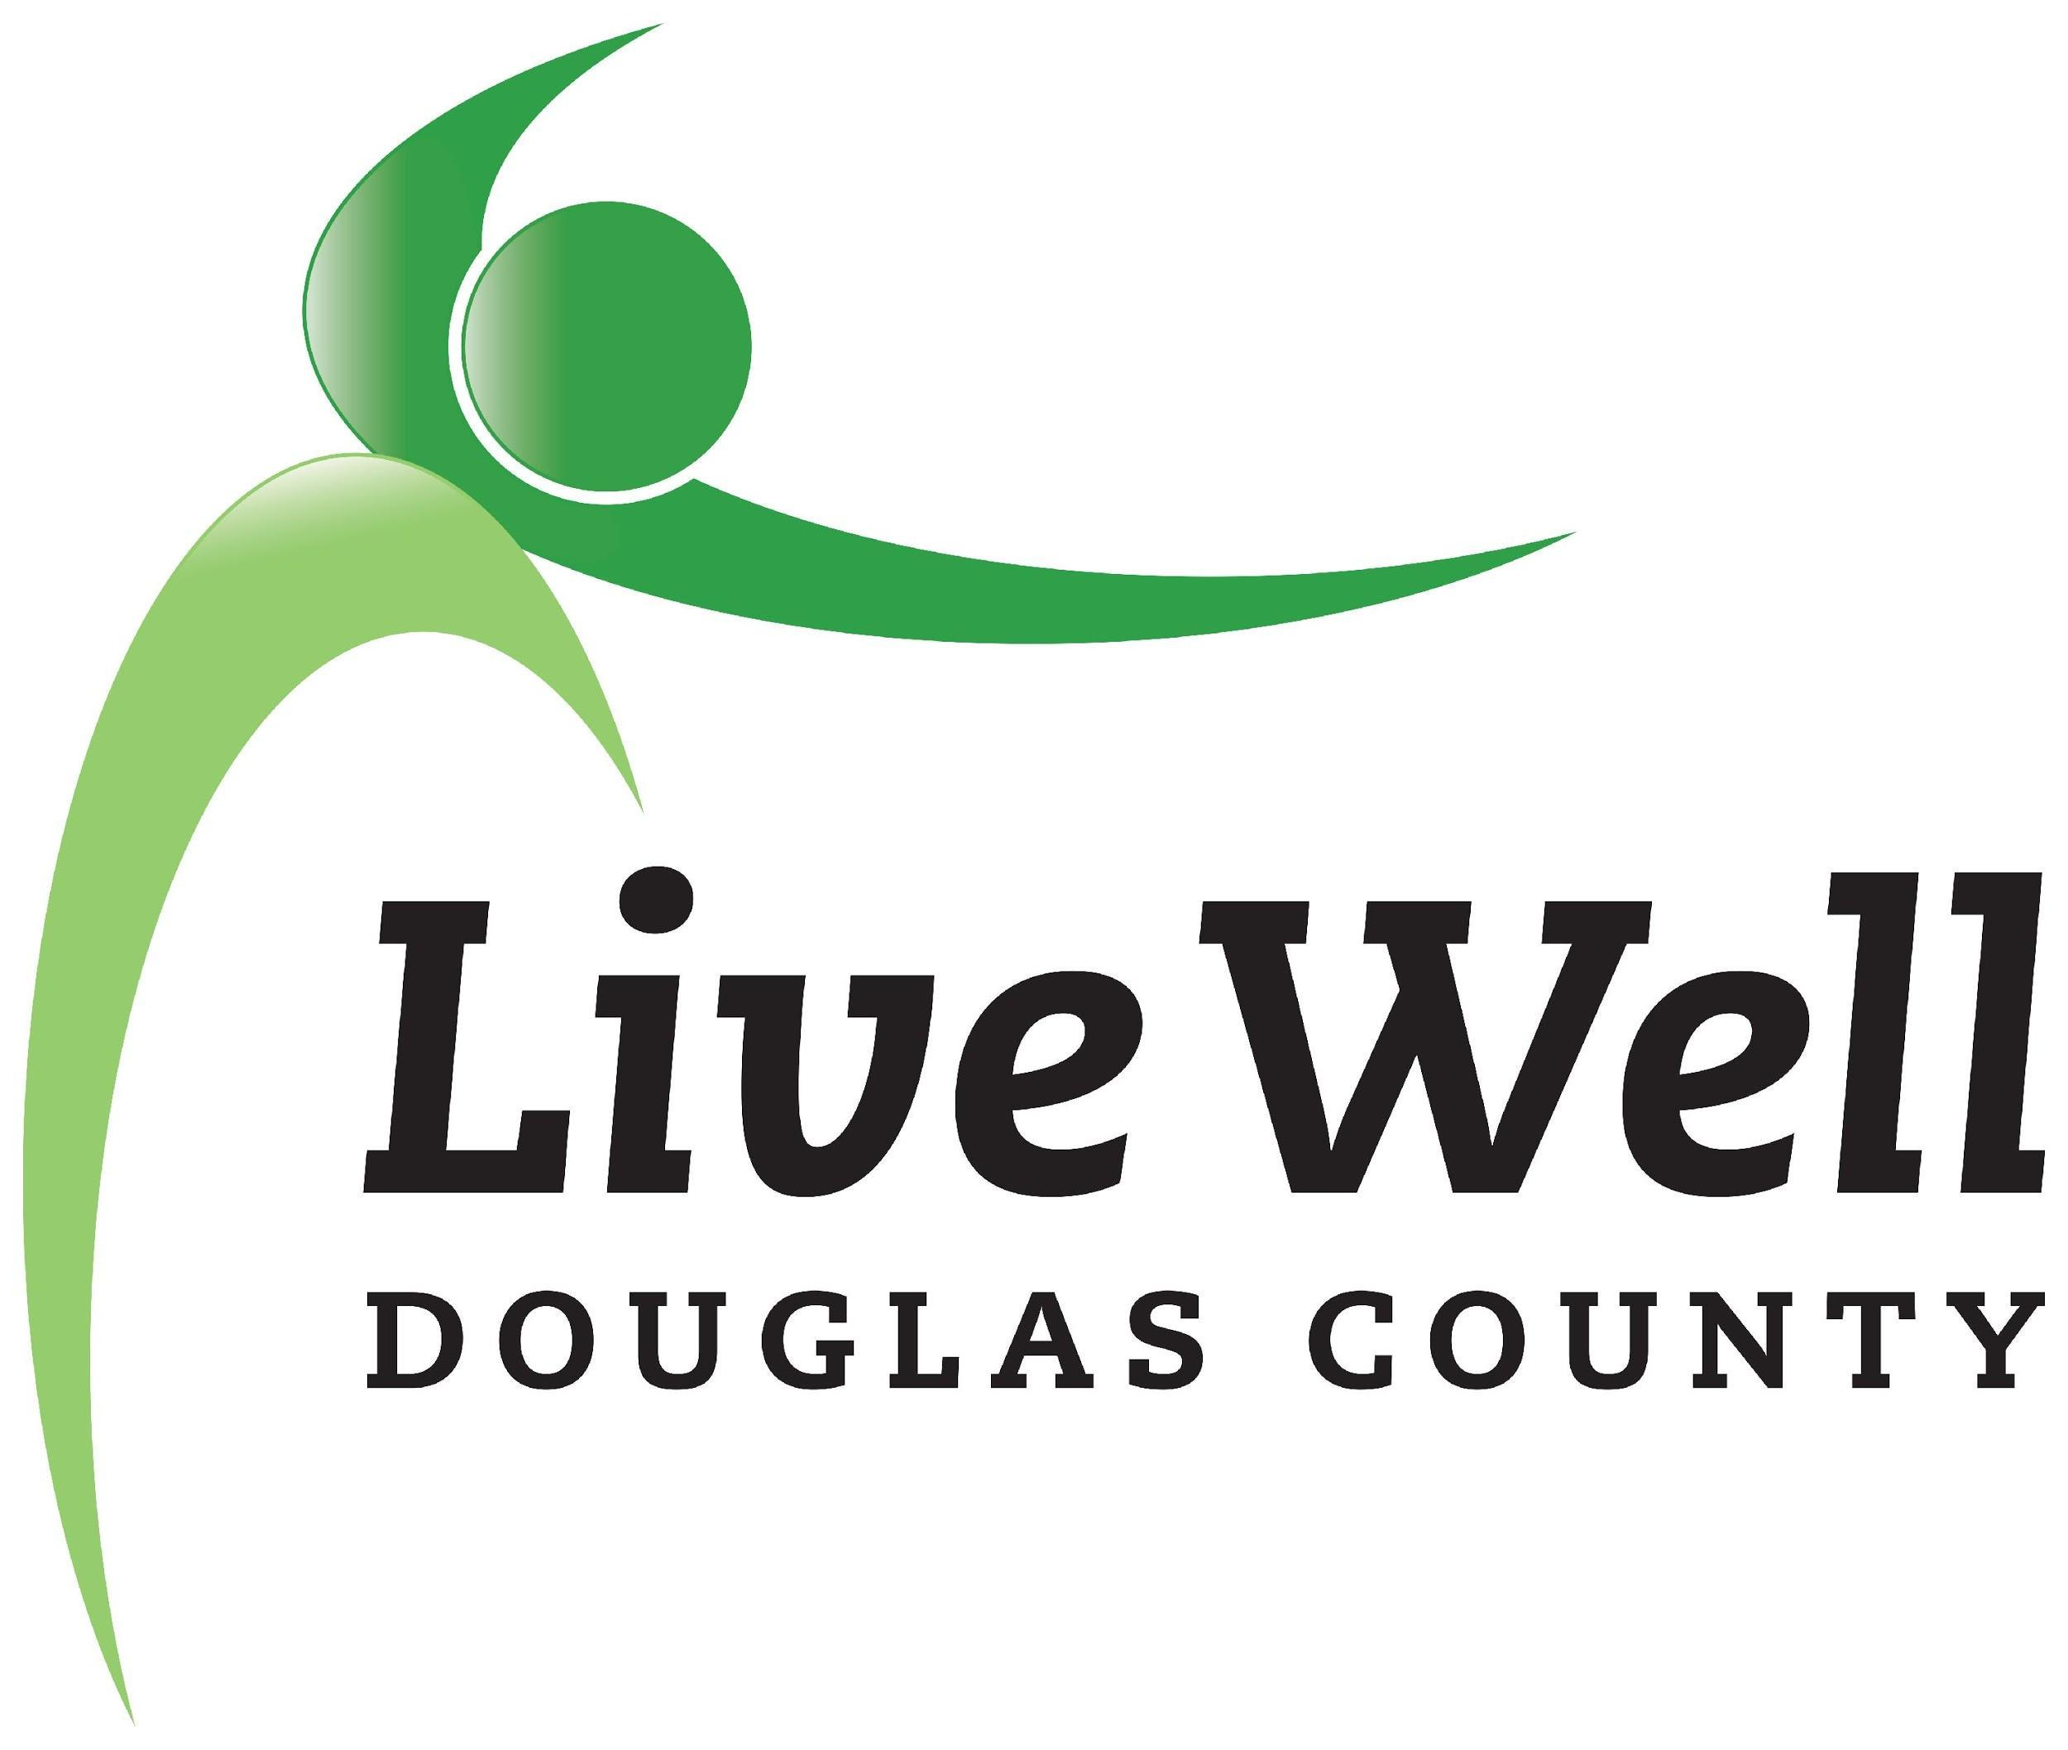
LiveWell Executive Team
Meeting Agenda

March 19, 2021, 11:00-12:30pm
Online via Zoom

Item | Notes | Action steps/Minutes
General Updates | - “Political advocacy” - Bolder Advocacy Resources  - Others | Review resources  - Public Charities Can Lobby  - Administrative Advocacy  - IRS Lobbying Flowchart  - Who is a legislator  Organization tax status: use of tax umbrella under KSRE, 501c3, 501c4  Marty to follow up with Mary Marrow/technical support with BCBS
Programmatic Updates | - Package funding (below)  - Request to expend $720.00 for 36, $20.00 Downtown Lawrence gift cards (or $900.00 for 36 cards @ $25.00)  - BCBS April Impact Report:  - Please provide a quote from coalition leadership or a partner about the value of the Pathways work to your community. Be creative! (Approx. 15-25 words).  - Describe your coalition, including your mission or vision, if applicable. (Approx. 50-60 words).  - Tell us about a package that you are excited about to promote healthy eating. Reminder: Write like you are talking to a member of your community. (Approx. 40-50 words).  - Tell us about a package that you are excited about to promote active living. Reminder: Write like you are talking to a member of your community.  - Tell us about a package that you are excited about to address commercial tobacco control.  - Please provide three key findings from your Community Perception Data Collection (e.g., focus groups, key informant interviews or survey) that stood out to your coalition).  - Please report how many partners you have engaged in the Pathways work.  - Confirm the number of packages you will be working on in Action Period 1. | Workgroups to develop spending plans with Marty, share maximum amounts available per package  Draw down other grant dollars/compliment (e.g. Nutrition Incentive Hub)  Utilize existing data on DUFB barriers  Outreach and advertising dollars  Mini-grants to partners (e.g. youth and young-person led tobacco prevention groups)  HBE should have no problem spending down money (based on historical projects like educational materials and infrastructure)  Healthy Food Rx Program  Explore the possibility of using the Community Checkbox to document BCBS package-specific deliverables/progress (decision is up to Public Health)  Christina will get details to Valorie with specific modifications - need to be able to keep CHP and grant deliverables separable, current system doesn’t allow this - need for modification; plan to meet end of April
Budget | - See document prepared by Marlin | Remaining funds at Public Health, cost to maintain online resources (website, etc) - potential to change online platform/website; need to train more people to use website  Valorie shared regular expenses amount ($1,700/year)  Joey will invite George to future meeting to discuss expenses, options
New Business | - Updating Bylaws

Six Pathways | Packages Being Implemented | Minimum Amount Available | Maximum Amount Available
Community & Social Context | Commercial Tobacco 21 | $1,000.00 | $30,000.00
 | Place Making | $1,000.00 | $50,000.00
Neighborhood & Physical Environment | Safe Routes to School /Multimodal Transportation | $1,000.00 | $100,000.00
Food | Safe Routes to Food | $1,000.00 | $100,000.00
 | Simply Produce | $5,000.00 | $20,000.00
Education | Tobacco-Free Campuses | $1,000.00 | $25,000.00
Health Care | Healthy Food RX Prescription Program | $10,000.00 | $20,000.00
Economic Stability | Double Up Food Bucks | $1,000.00 | $5,000.00
 | Food Pantry / Hunger Relief | $5,000.00 | $25,000.00
 |  | $26,000.00 | $375,000.00

